DAY 8
Date: 7/6/2025
Task021: 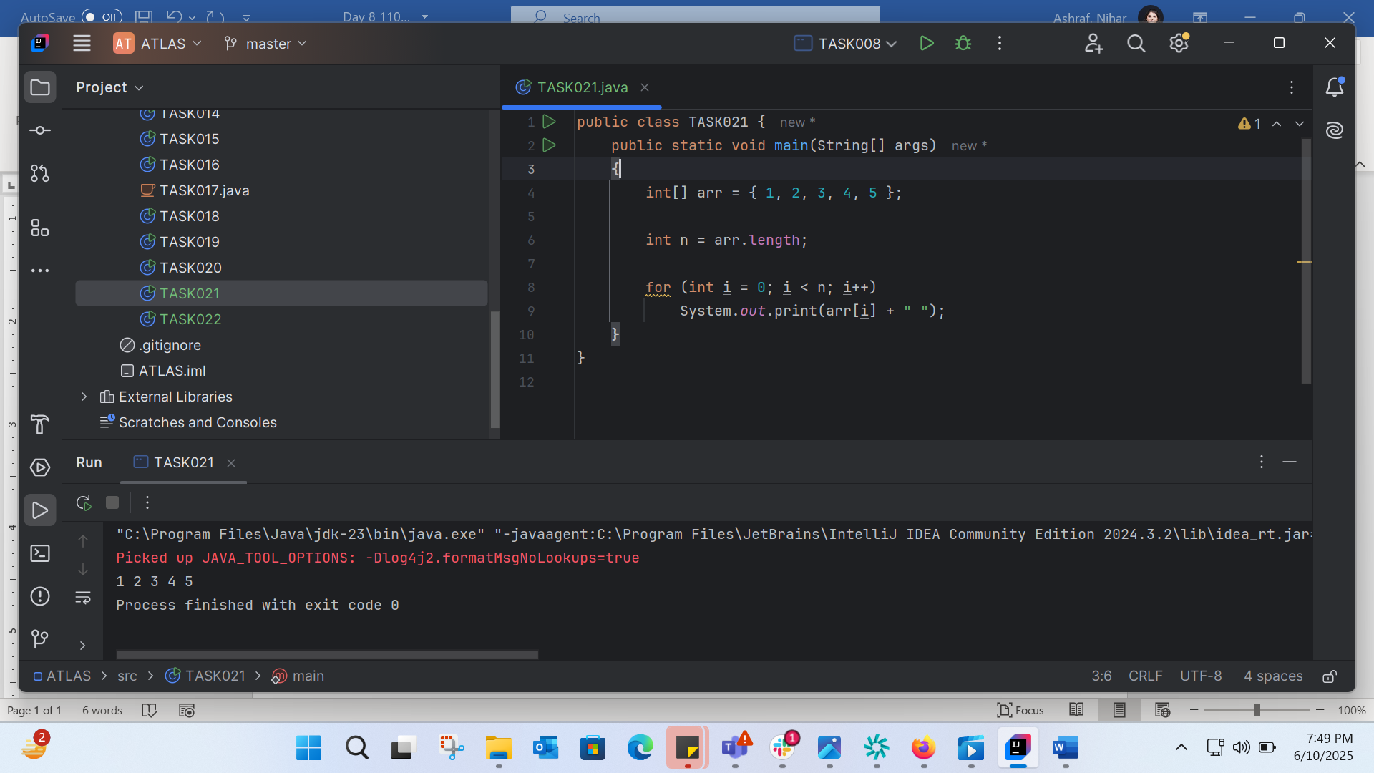
TASK022: 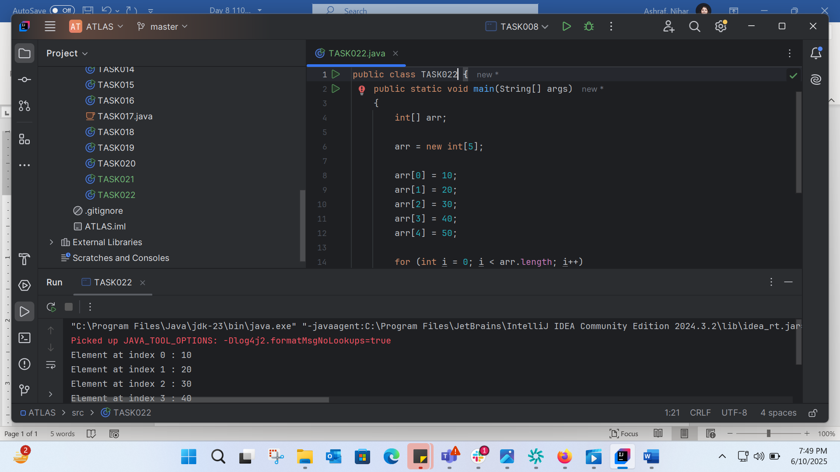
TASK023: 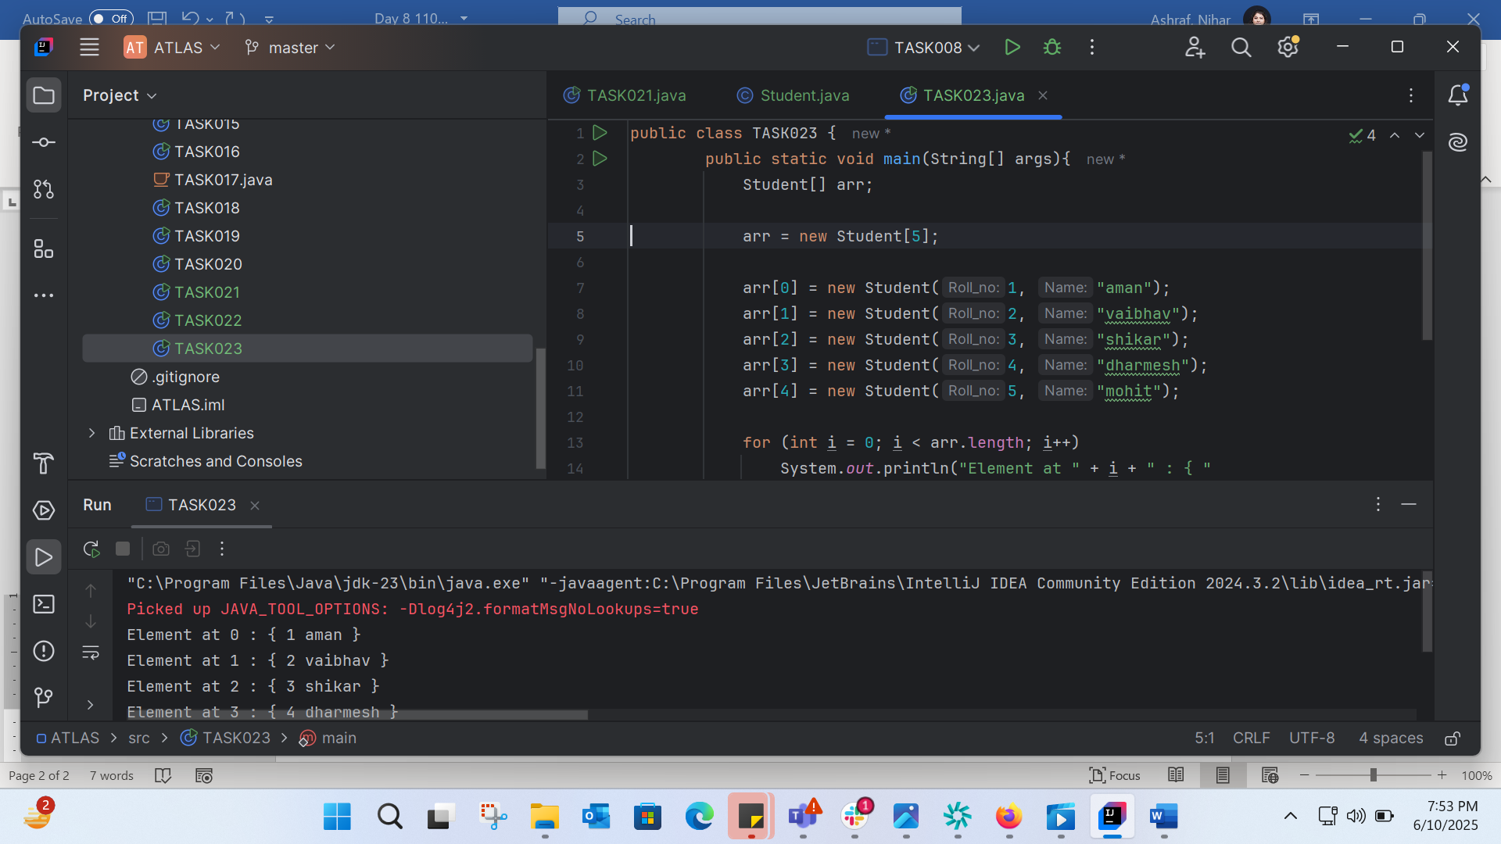
TASK024:
Without Override: 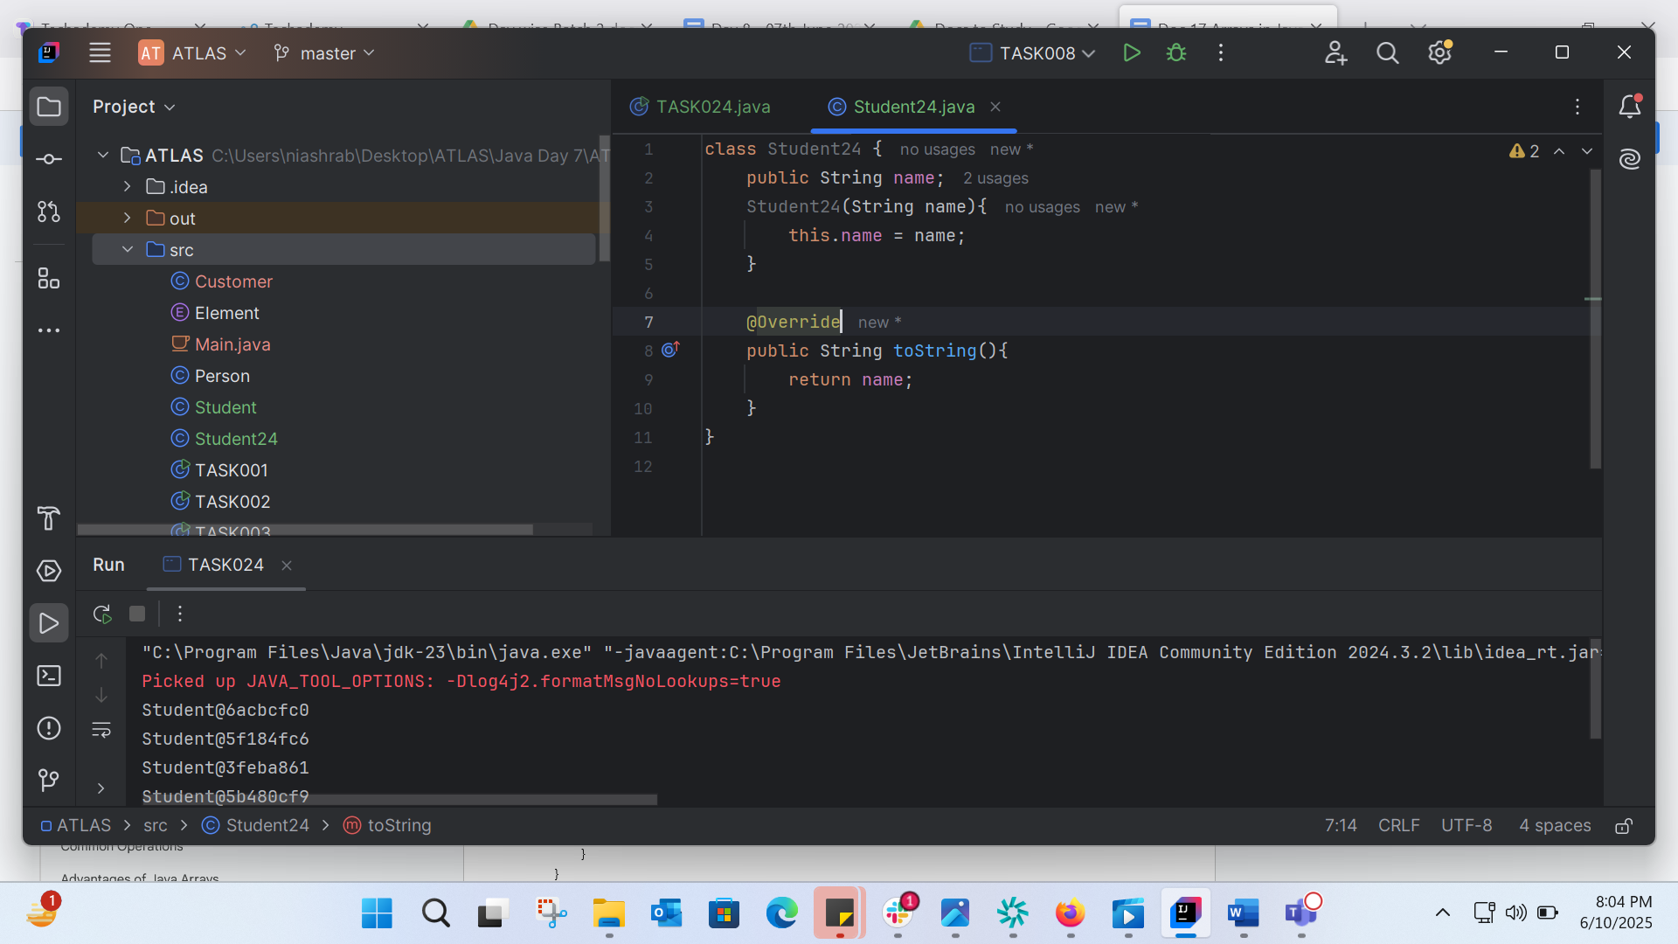
With override: 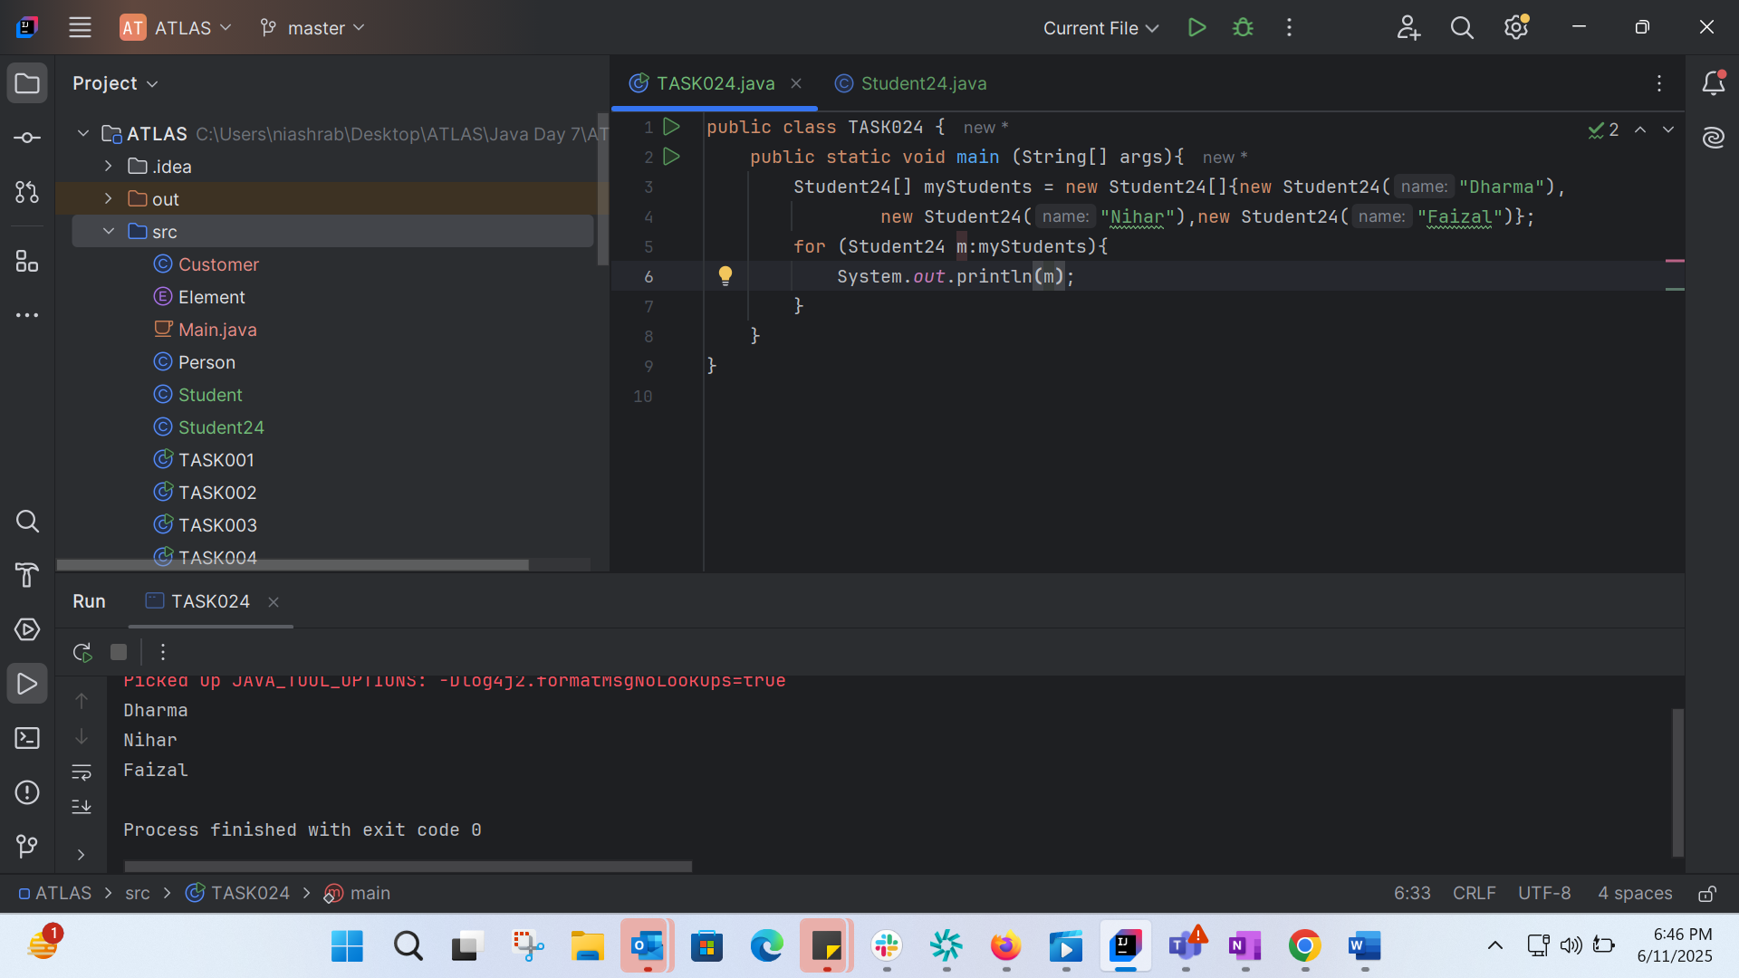
TASK025: 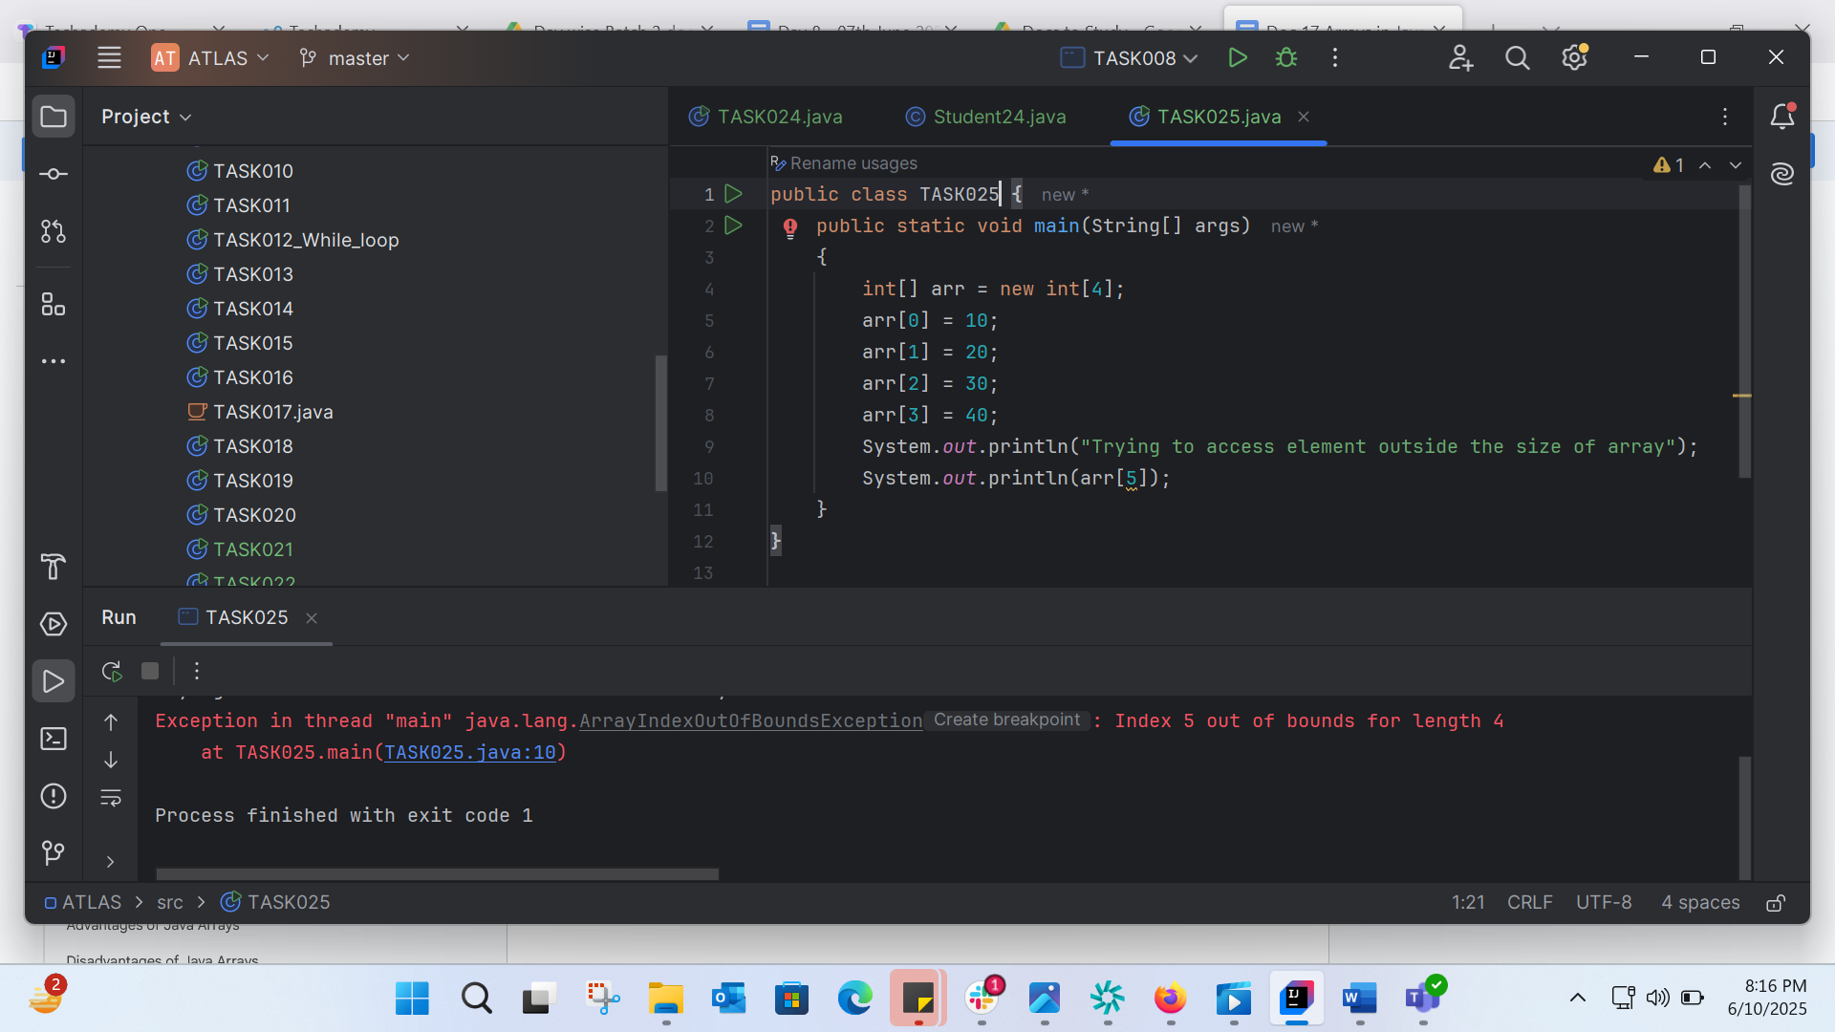
Cant bcz array size is 4.
TASK026: 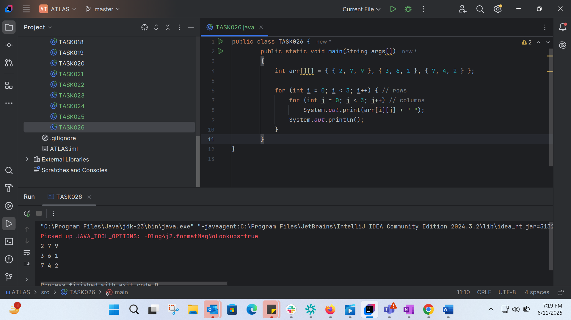
TASK27: 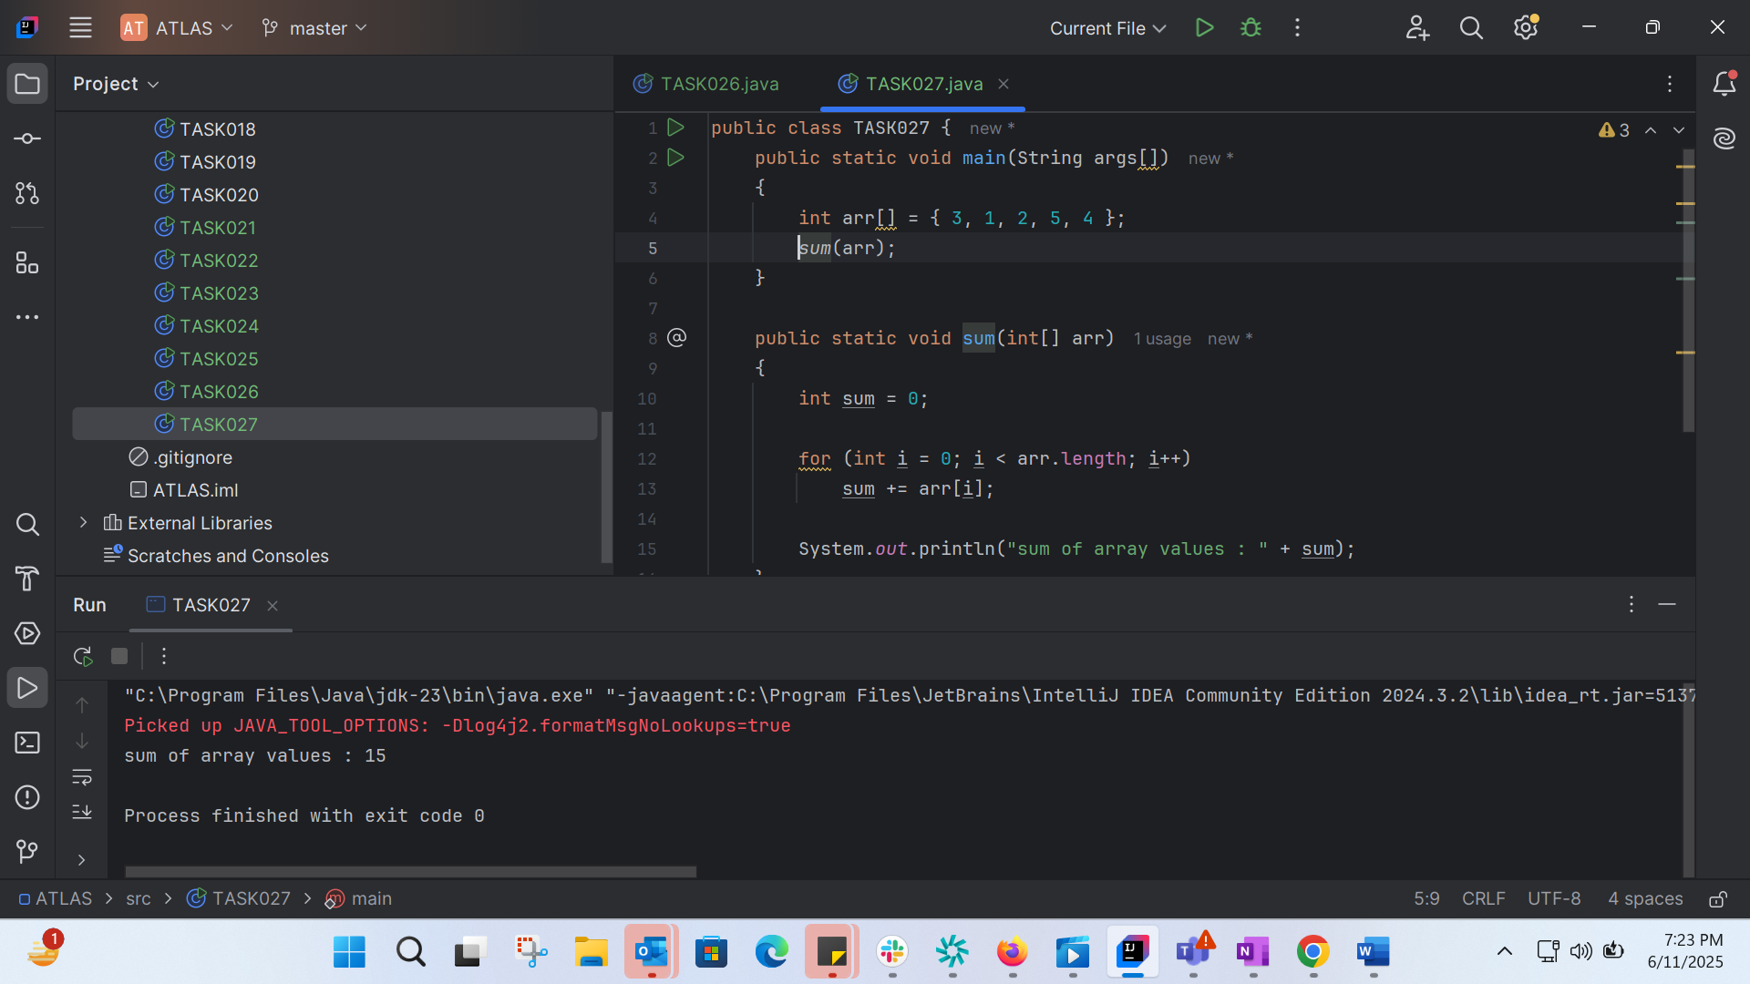
TASK28: 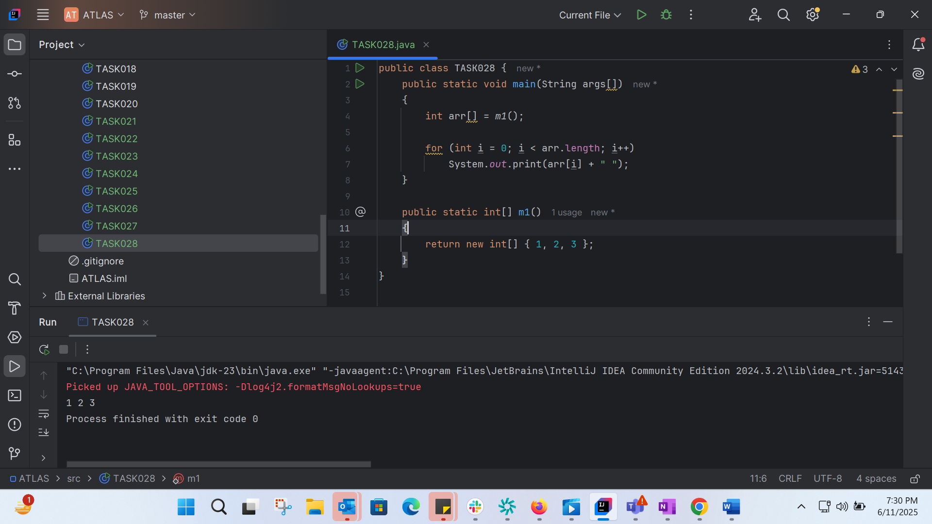
TASK29: 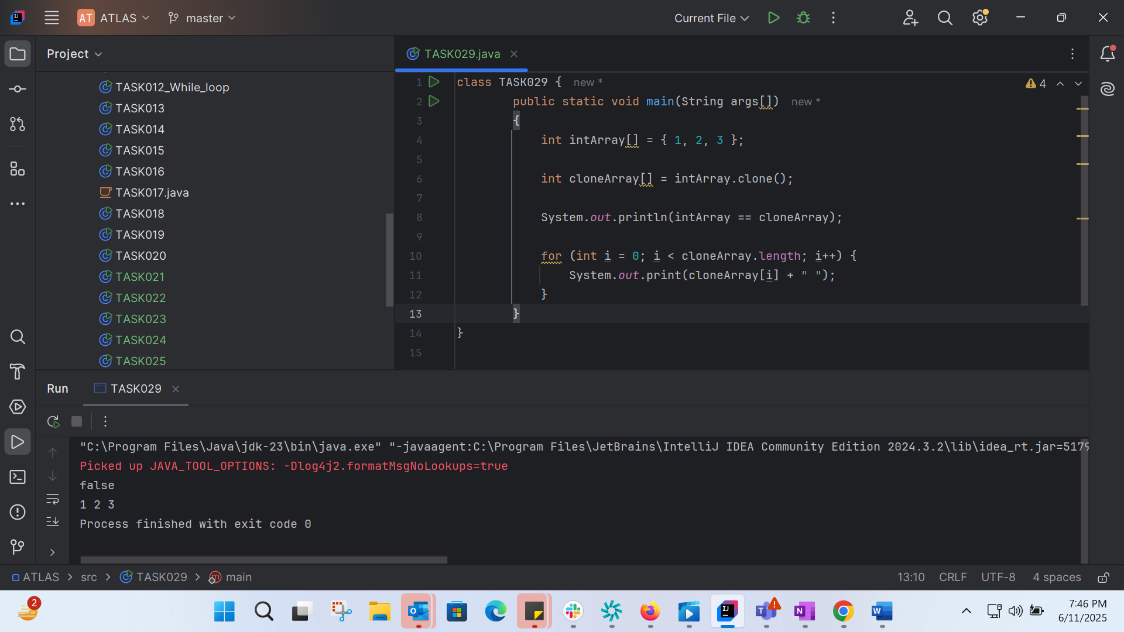
Task30: 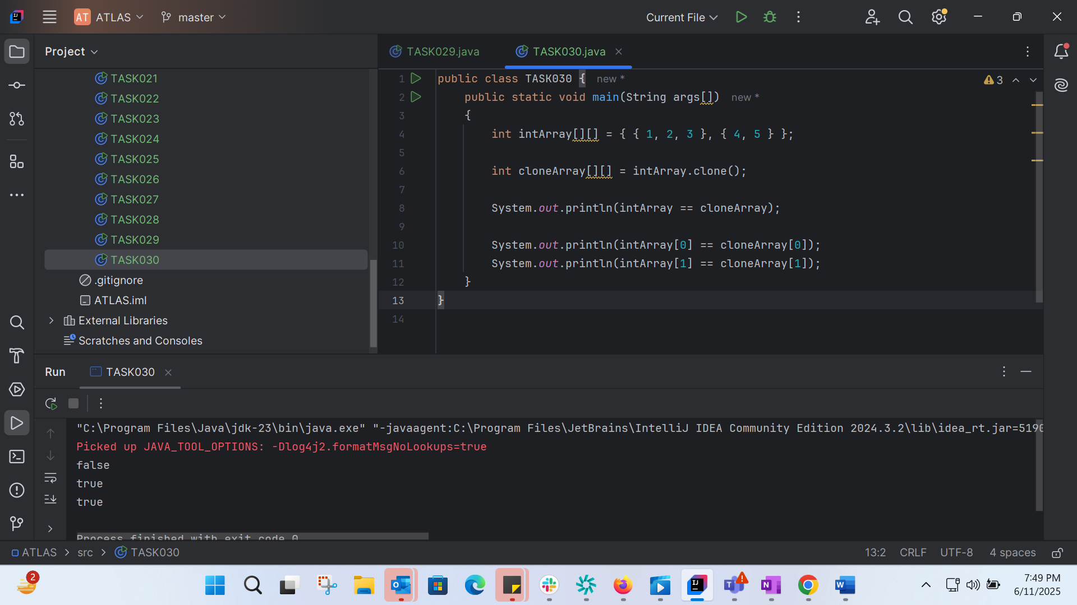
TASK31: 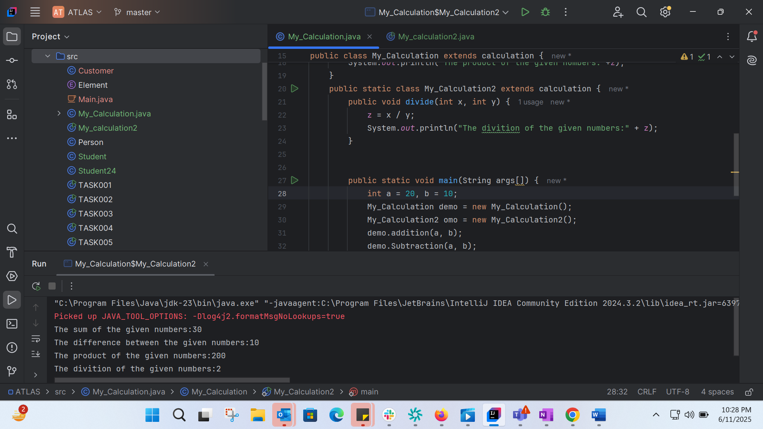
TASK 32:
Multiple inheretance is not supported in Java
TASK33:
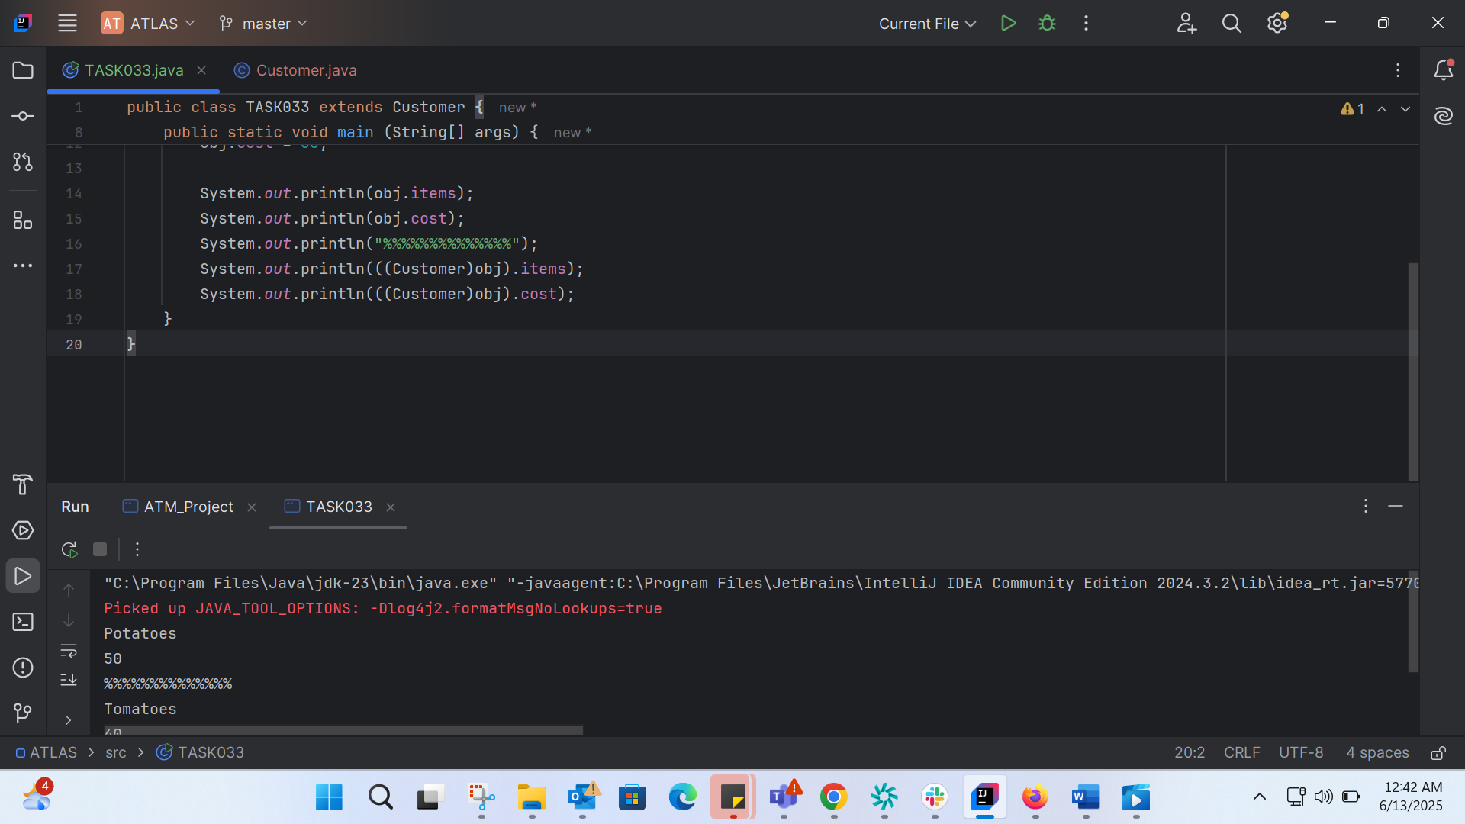
TASK 34:
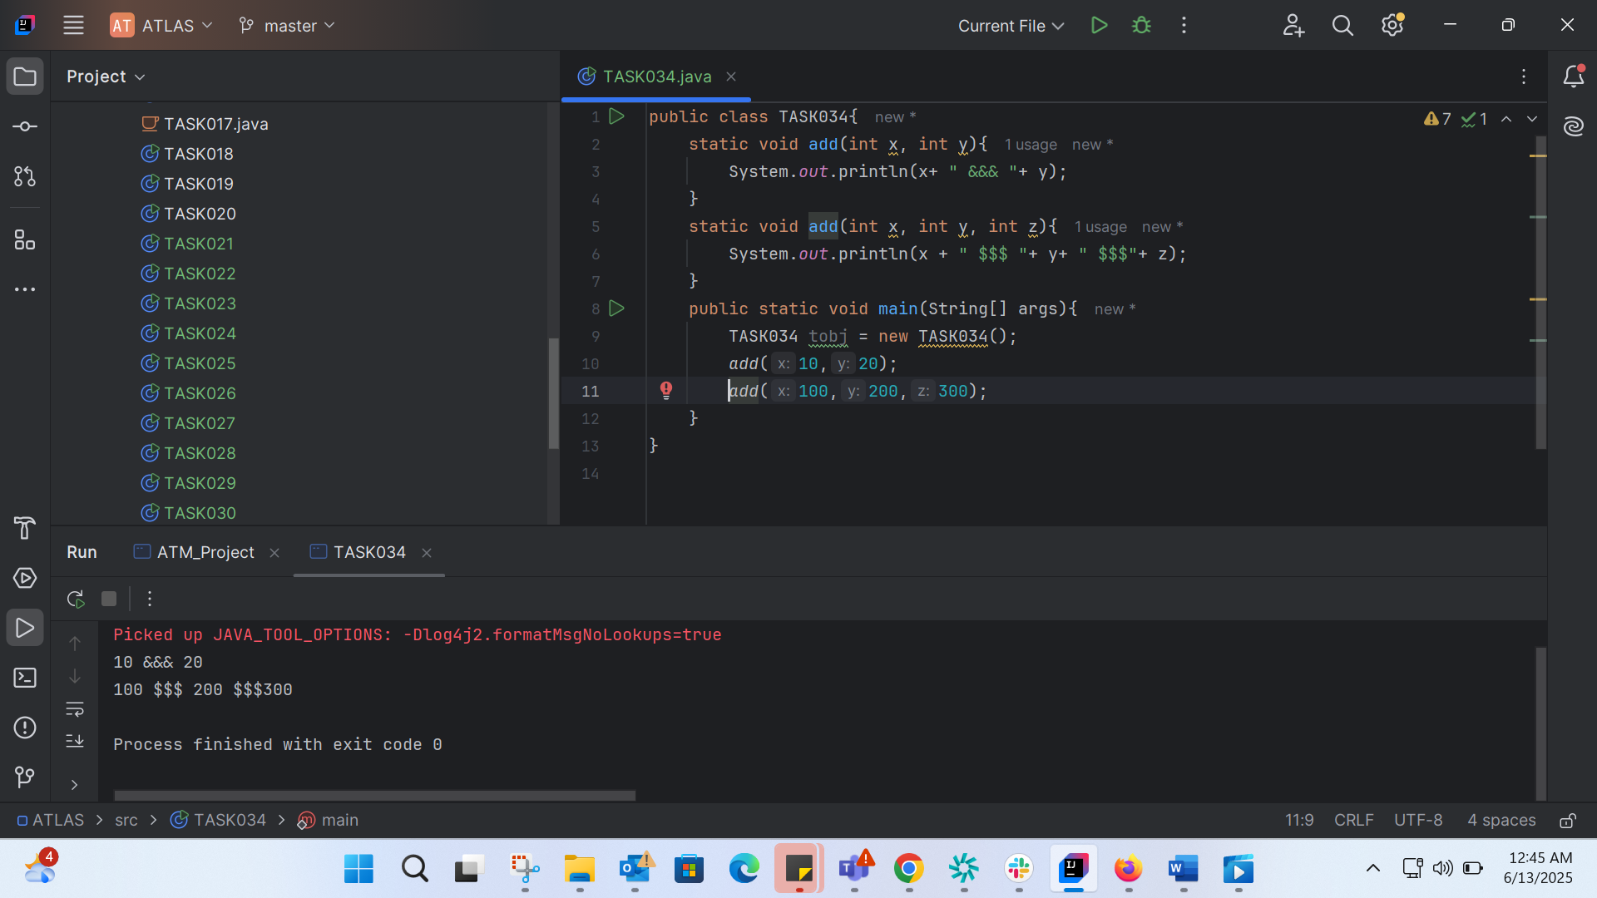
TASK035:
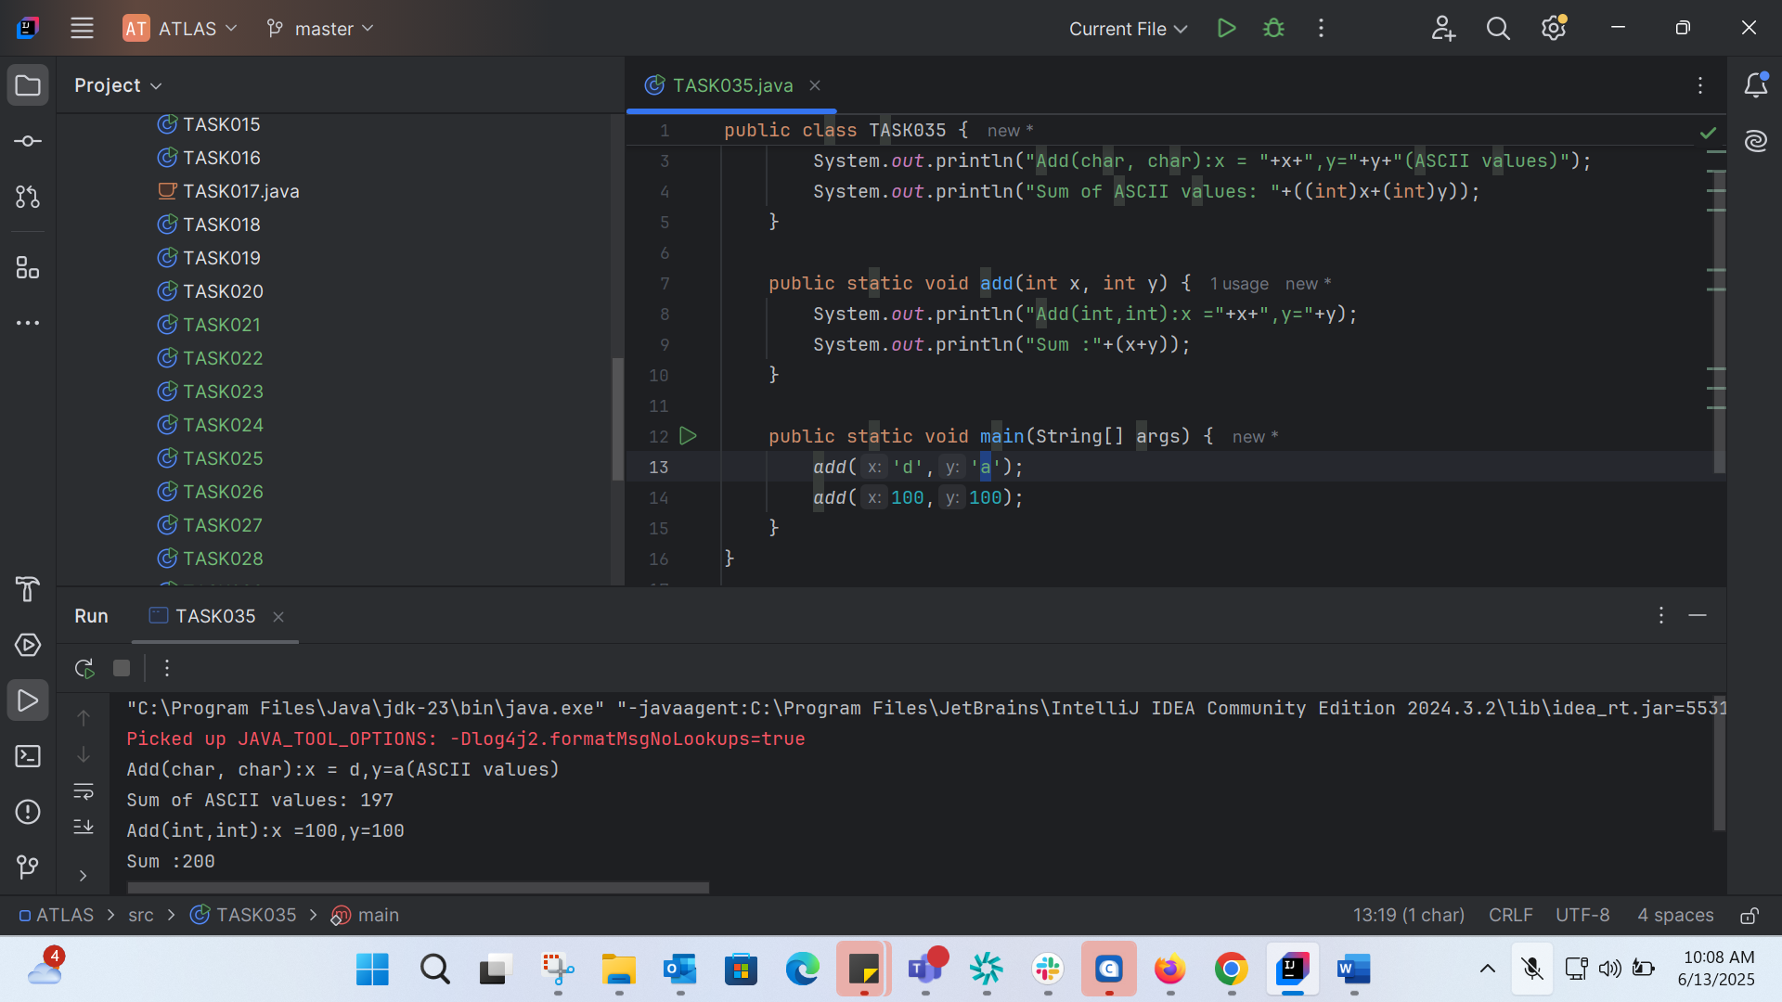
TASK036: 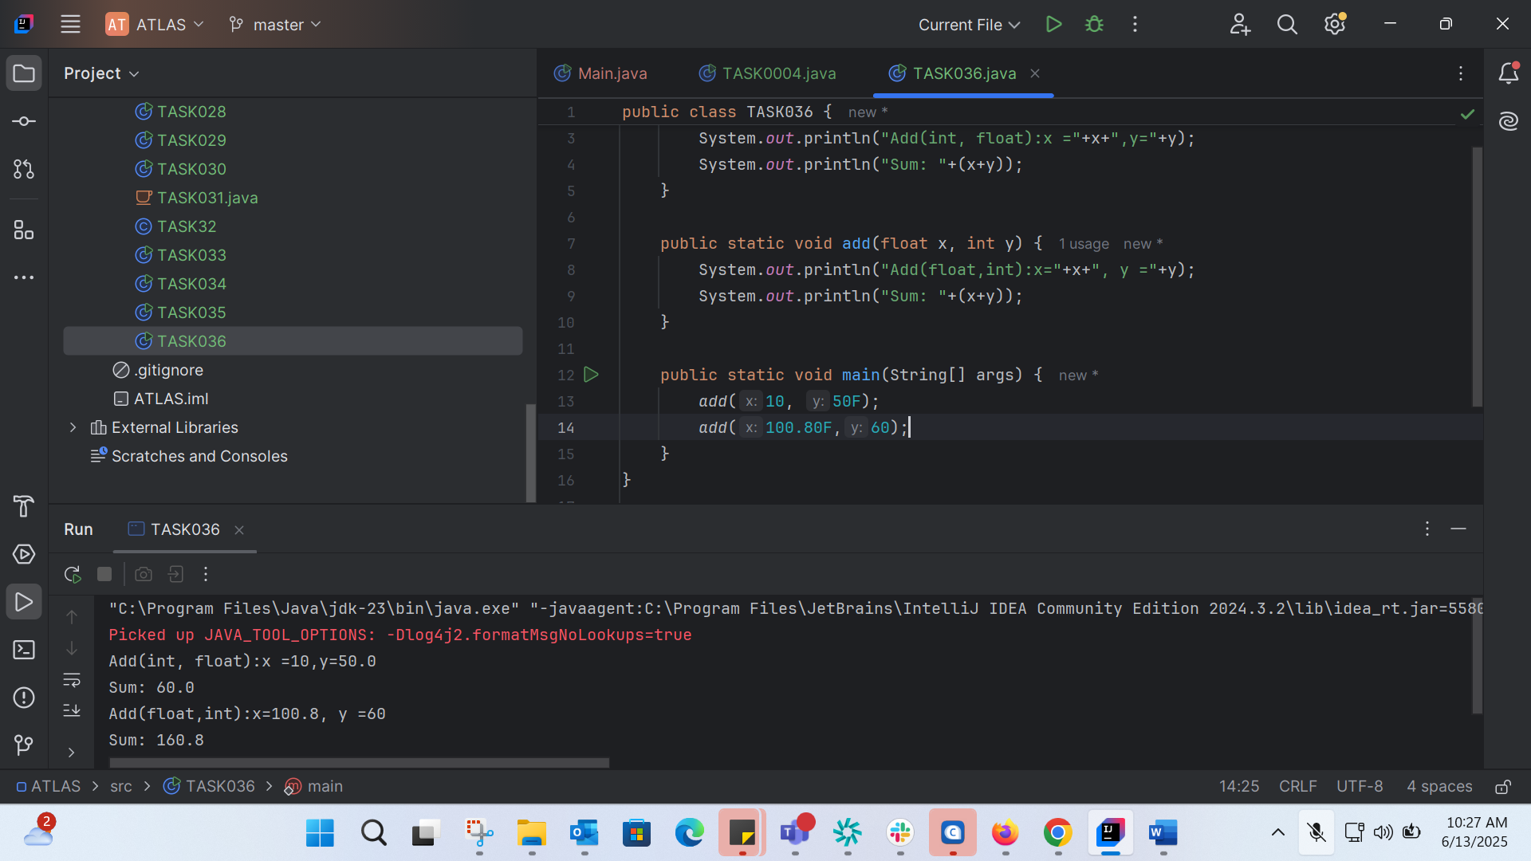

TASK37:
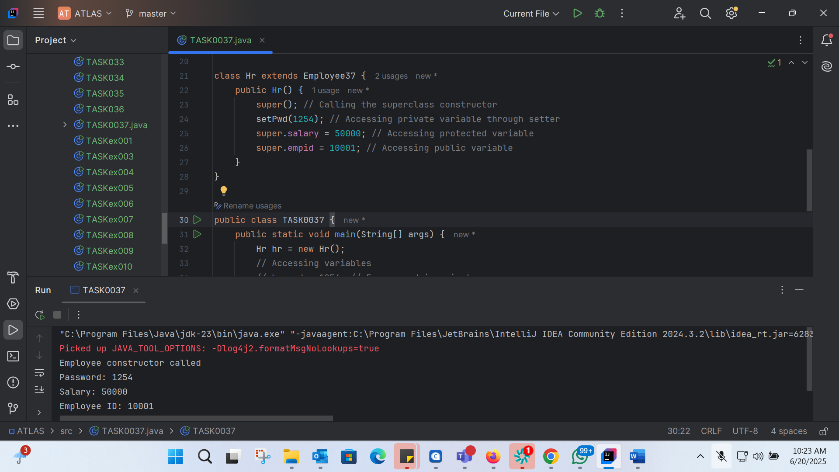
class Employee37 {
private int pwd;
protected int salary;
public int empid;
// Constructor
public Employee37() {
System.out.println("Employee constructor called");
}
// Getters and setters for private variables
public int getPwd() {
return pwd;
}
public void setPwd(int pwd) {
this.pwd = pwd;
}
}
class Hr extends Employee37 {
public Hr() {
super(); // Calling the superclass constructor
setPwd(1254); // Accessing private variable through setter
super.salary = 50000; // Accessing protected variable
super.empid = 10001; // Accessing public variable
}
}
public class TASK0037 {
public static void main(String[] args) {
Hr hr = new Hr();
// Accessing variables
// hr.pwd = 1254; // Error: pwd is private
hr.setPwd(1254); // Accessing private variable through setter
hr.salary = 50000; // Accessing protected variable
hr.empid = 10001; // Accessing public variable
System.out.println("Password: " + hr.getPwd());
System.out.println("Salary: " + hr.salary);
System.out.println("Employee ID: " + hr.empid);
}
}
TASK38:
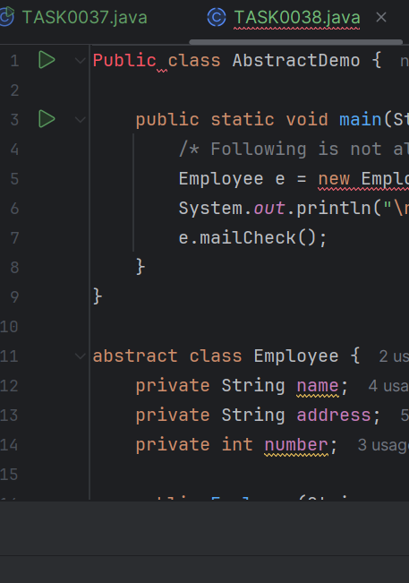

TASK 39:
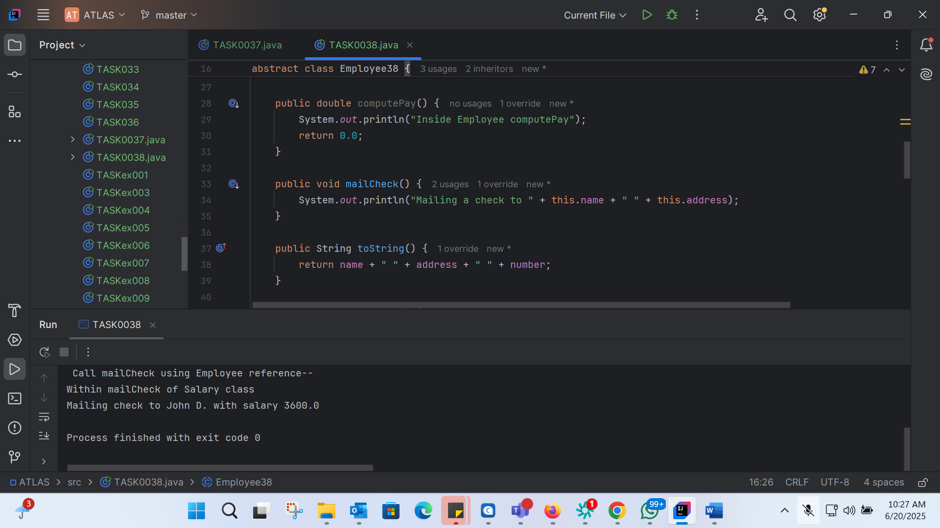
public class TASK0038 {
public static void main(String[] args) {
// Create an instance of Salary (concrete subclass)
Salary s = new Salary("George W.", "Houston, TX", 43, 3600.00);
Employee38 e = new Salary("John D.", "Houston, TX", 43, 3600.00); // Using Employee reference
System.out.println("\n Call mailCheck using Salary reference--");
s.mailCheck();
System.out.println("\n Call mailCheck using Employee reference--");
e.mailCheck();
}
}
// Abstract class Employee
abstract class Employee38 {
private String name;
private String address;
private int number;
public Employee38(String name, String address, int number) {
System.out.println("Constructing an Employee");
this.name = name;
this.address = address;
this.number = number;
}
public double computePay() {
System.out.println("Inside Employee computePay");
return 0.0;
}
public void mailCheck() {
System.out.println("Mailing a check to " + this.name + " " + this.address);
}
public String toString() {
return name + " " + address + " " + number;
}
public String getName() {
return name;
}
public String getAddress() {
return address;
}
public void setAddress(String newAddress) {
address = newAddress;
}
public int getNumber() {
return number;
}
}
// Concrete subclass Salary
class Salary extends Employee38 {
private double salary; // Annual salary
public Salary(String name, String address, int number, double salary) {
super(name, address, number);
setSalary(salary);
}
public void mailCheck() {
System.out.println("Within mailCheck of Salary class ");
System.out.println("Mailing check to " + getName() + " with salary " + salary);
}
public double getSalary() {
return salary;
}
public void setSalary(double newSalary) {
if (newSalary >= 0.0) {
salary = newSalary;
}
}
public double computePay() {
System.out.println("Computing salary pay for " + getName());
return salary / 52;
}
}

TASK40:
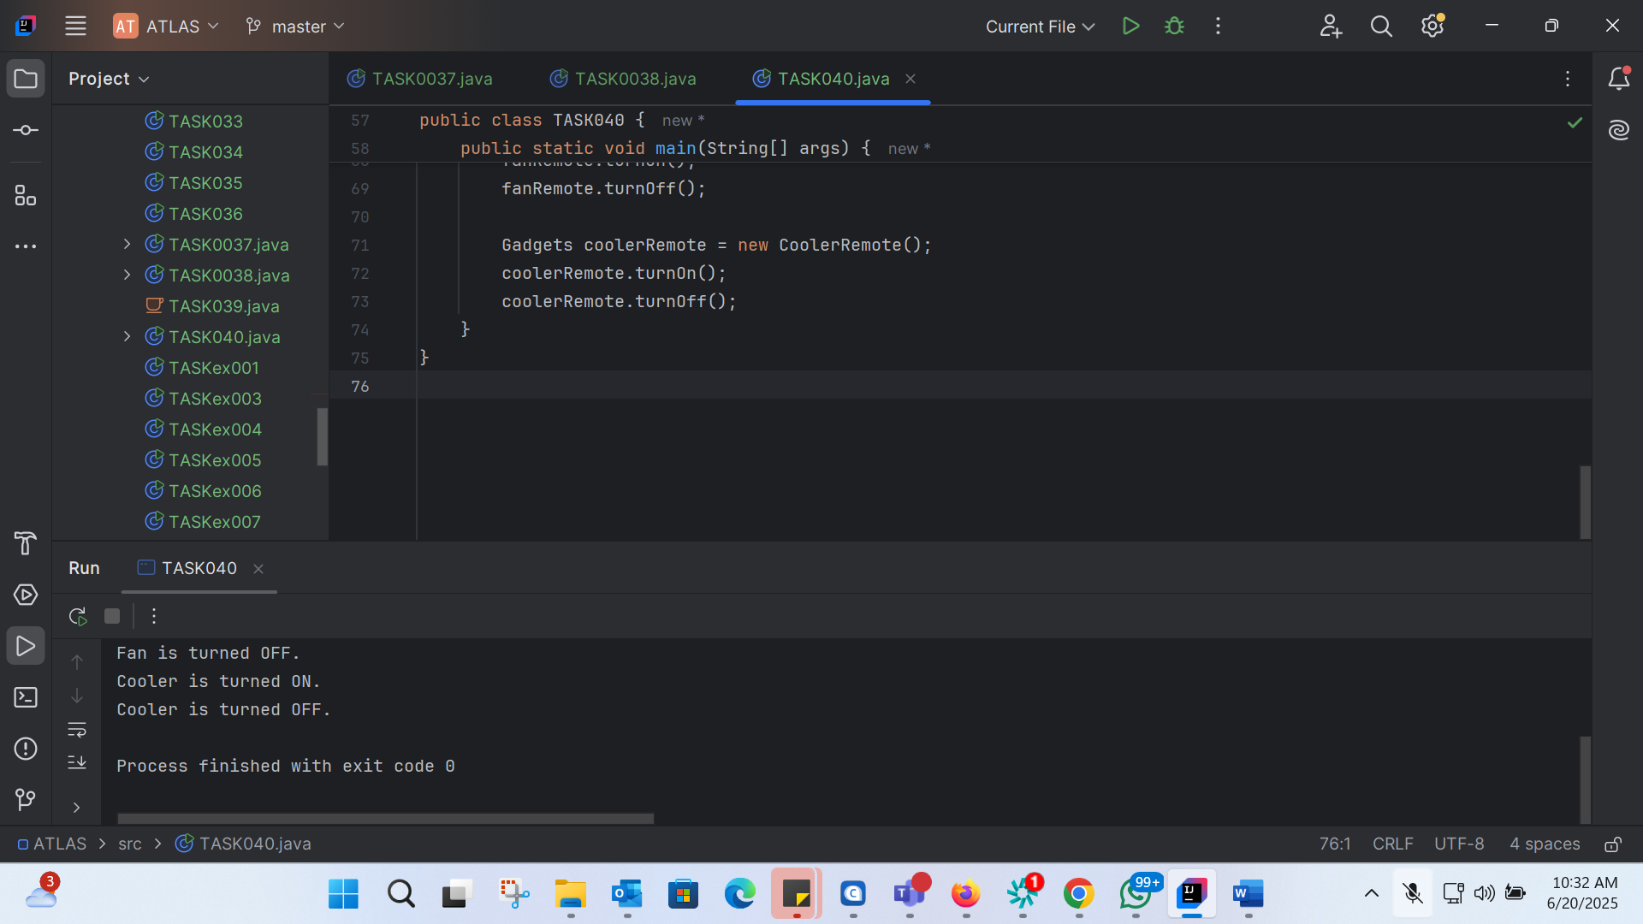
// Working of Abstraction in Java
abstract class Gadgets {
public abstract void turnOn();
public abstract void turnOff();
}
// Concrete class implementing the abstract methods
class TVRemote extends Gadgets {
@Override
public void turnOn() {
System.out.println("TV is turned ON.");
}
@Override
public void turnOff() {
System.out.println("TV is turned OFF.");
}
}
class ACRemote extends Gadgets {
@Override
public void turnOn() {
System.out.println("AC is turned ON.");
}
@Override
public void turnOff() {
System.out.println("AC is turned OFF.");
}
}
class FanRemote extends Gadgets {
@Override
public void turnOn() {
System.out.println("Fan is turned ON.");
}
@Override
public void turnOff() {
System.out.println("Fan is turned OFF.");
}
}
class CoolerRemote extends Gadgets {
@Override
public void turnOn() {
System.out.println("Cooler is turned ON.");
}
@Override
public void turnOff() {
System.out.println("Cooler is turned OFF.");
}
}
// Main class to demonstrate abstraction
public class TASK040 {
public static void main(String[] args) {
Gadgets tvRemote = new TVRemote();
tvRemote.turnOn();
tvRemote.turnOff();
Gadgets acRemote = new ACRemote();
acRemote.turnOn();
acRemote.turnOff();
Gadgets fanRemote = new FanRemote();
fanRemote.turnOn();
fanRemote.turnOff();
Gadgets coolerRemote = new CoolerRemote();
coolerRemote.turnOn();
coolerRemote.turnOff();
}
}

TASK041:
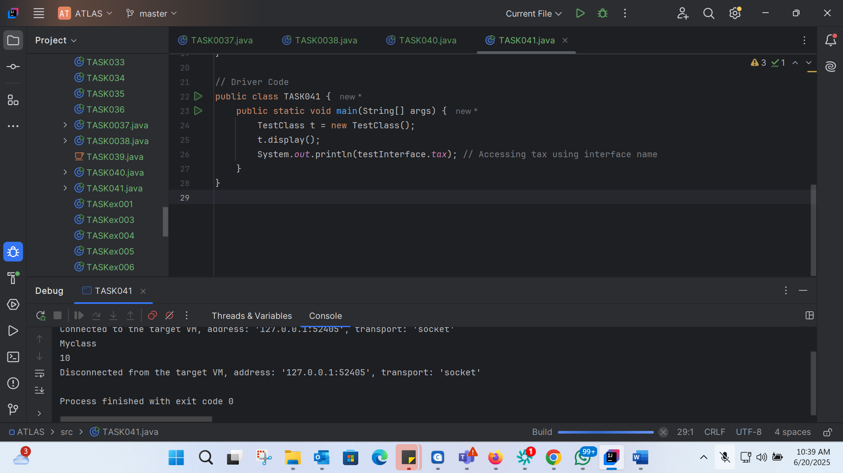
import java.io.*;
// Interface Declared
interface testInterface {
// public, static and final
final int tax = 10;
// public and abstract
void display();
}
// Class implementing interface
class TestClass implements testInterface {
// Implementing the capabilities of Interface
@Override
public void display() {
System.out.println("Myclass");
}
}
// Driver Code
public class TASK041 {
public static void main(String[] args) {
TestClass t = new TestClass();
t.display();
System.out.println(testInterface.tax); // Accessing tax using interface name
}
}

TASK042:
Constants:

- Constants are values that do not change during the execution of a program.
- In Java, constants are typically declared using the final keyword along with static.
- Constants are usually declared at the class level and are shared by all instances of the class.

Final Variables:

- Final variables are variables that can be assigned a value only once.
- Once a final variable is assigned a value, it cannot be reassigned.
- Final variables can be declared at the class level, instance level, or local level.

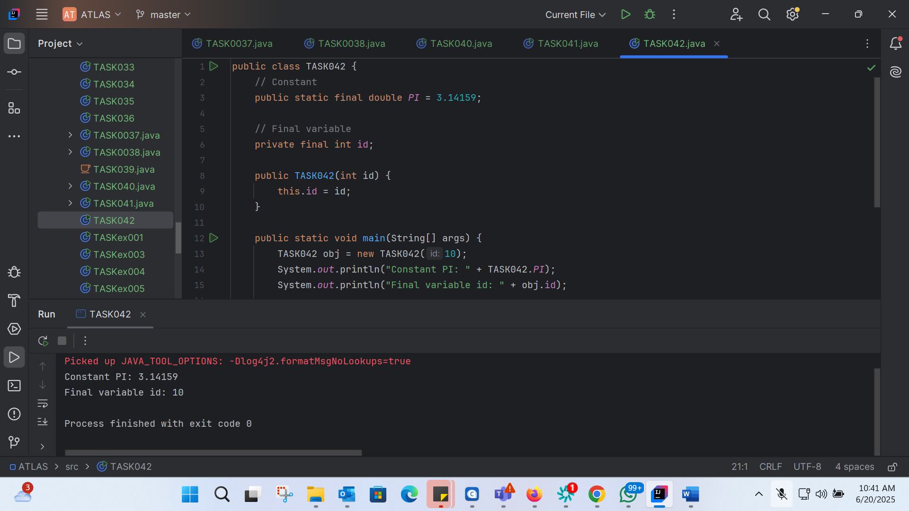
public class TASK042 {
// Constant
public static final double PI = 3.14159;
// Final variable
private final int id;
public TASK042(int id) {
this.id = id;
}
public static void main(String[] args) {
TASK042 obj = new TASK042(10);
System.out.println("Constant PI: " + TASK042.PI);
System.out.println("Final variable id: " + obj.id);
// Trying to reassign a value to a final variable will result in a compile-time error
// obj.id = 20; // Uncommenting this line will cause a compile-time error
}
}

